INTEGRATING BOWTIE ANALYSIS INTO BAND SAW MAINTENANCE

T. K. Tsapi^{I}*, M. K. Tongwa² and B. D. Soh³
^{I,2}*Department of Mechanical and Industrial Engineering, National Higher Polytechnic Institute,
University of Bamenda, P.O Box, 39 Bambili, Cameroon.
³Department of Mechanical Engineering, Bandjoun University Institute of Technology,
University of Dschang, P.O. Box: 134, Bandjoun, Cameroon
*Corresponding author's email address: tsapimartial@yahoo.com

ARTICLE INFORMATION

Submitted 29 February, 2024
Revised 25 March, 2024
Accepted 4 April, 2024

Keywords:
Bowtie Analysis
Band saw
Cutting Machines
Maintenance Manufacturing

ABSTRACT
Sawing machines used to cut raw materials to desired dimensions in industrial manufacturing operations are of great importance. Occupational injuries have occurred in the past as a result of failures in the risk management of these machines. In this paper, Bowtie analysis-based risk identification is developed based on the diagnosis of band saw cutting machine components. The results of the Bowtie risk assessment for hazards associated with the impeller, pump housing, saw blade, clamp, and seal pump were developed to structure the decision-making process with better information visualization. Hazards in the Bowtie were used to describe the root causes of failure (threats) that were identified, such as inadequate maintenance planning, foreign objects entering the pump, and inadequate maintenance. Based on the Bowtie diagrams, which capture the sufficient complexity of the real system behavior, the cutting tool was maintained following a corrective action plan that was developed. The assessment of the band saw performance rate after maintenance was 93%. This demonstrates that decision-makers can manage risk and reinforce a work culture that prioritizes actions to improve maintenance and safety outcomes using the Bowtie analysis method.

- Introduction
The semi-automatic band saw works on the principle of using a continuous toothed blade to cut metal sheets and bars. It is widely used in the woodworking, light, food, and metalworking industries where precision cutting is required (Tsapi et al., 2024, Kuldipia et al., 2023, Kohale et al., 2022). It is designed to provide higher efficiency and accuracy compared to traditional hand-operated tools such as hacksaws and angle grinders (Xue et al., 2024). Depending on the lateral flexibility and width of the band, band saws can be used to cut straight, irregular, or curved shapes (Alisinoglu et al., 2019). By automating the cutting process, the band saw reduces the risk of accidents and injuries that can occur with hand-operated tools.
The semi-automatic band saw at Rolling Enterprise, located in the Northwest Region of Cameroon, was out of service. The company is involved in the machining of metal parts for automobiles. The company provides services in automobile maintenance, medical equipment maintenance and installation, electrical and electronic maintenance, and welding and fabrication of various components and parts. The prolonged downtime of the band saw significantly impacted the productivity of the manufacturing unit, resulting in delays in delivery times and a decrease in customer satisfaction.
To address this issue, this research was initiated with the goal of rehabilitating the semi-automatic band saw, with a particular focus on improving the local work culture so that operators can develop a shared understanding of how their tasks contribute to the greater good of the company. This improves productivity and ensures timely delivery of products to customers. The Bowtie method, a visual risk assessment technique, was integrated into the corrective action process to analyze and communicate potential hazards, their causes, and related consequences and effects.
  - Materials and methods
  - Materials
The maintenance was performed on the band saw with the machine designation Behringer Band saw KS 280HY. The semi-automatic band saw machine consists of several components and subsystems that work together to perform cutting operations on materials. The basic block diagram of a semi-automatic band saw machine includes the following parts (Patil and Waghmode, 2014); material stock, base or bed, cutting blade, blade guides, clamping system, cutting head, motor, control panel, cooling system, and belt that controls blade speed and feed adjustment.
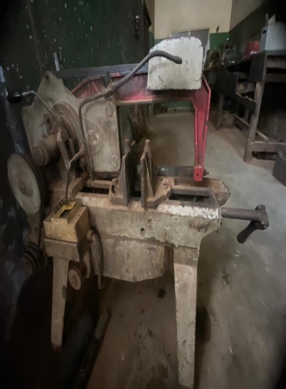
Figure I: Behringer band saw KS 280HY

Methods
Within the framework of the research, several methods were used in the investigation. First, the diagnostic process was performed, followed by the implementation of the "Bowtie Methodology" to provide an overview of the risk associated with component failure and to identify the root causes of the failures. A comprehensive corrective action plan was then formulated.
The Bowtie contains various risk elements; including hazards, root causes (threats), consequences, barriers and controls. The process for constructing the Bowtie diagram with the generic structure shown in Figure 2 was as follows:
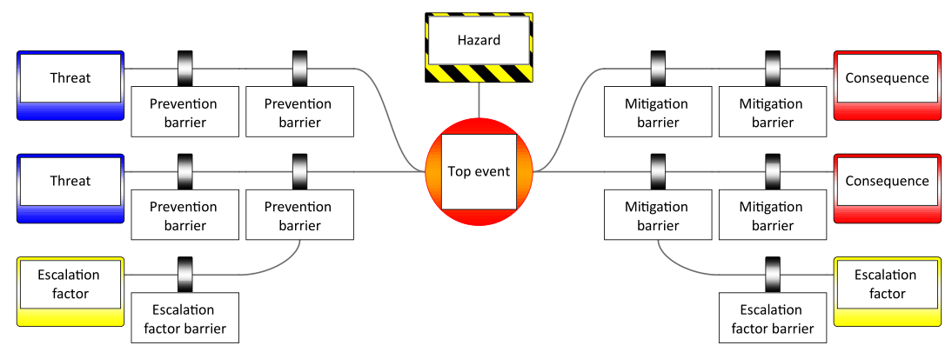
Figure 2: Generic structure of a Bowtie diagram (Aust and Pons, 2020)
- Hazard: Identifying the hazard, which sets the scope and context of the risk assessment, was the first step in constructing the Bowtie diagram for the semi-automatic band saw. The hazard represented any condition of the band saw components that had the potential to cause harm or damage, including injury, to personnel; damage to equipment, property, or the environment; loss of material; or reduction in the ability to perform a prescribed function (ICAO, 2012).
Start
End
Build a team
Problem identification: diagnosis, problem condition description
Corrective actions acceptable?
Determine root causes from Bowtie diagram
Determine corrective and preventive actions
YES
NoO

Figure 3: Methodology by steps for root cause analysis and corrective actions
(Tsapi et al., 2024)
- Top event: Defining the top event was the next step, describing the point at which we lose control of the hazard. It has not yet caused any damage or impact, but can lead to undesirable outcomes if all prevention barriers fail (Aust and Pons, 2020).
- Threats: Identify the threats that describe the causes that can lead to the release of the top event. In Bowtie, these threats are used to describe the root causes (Ispășoiu et al., 2021).
- Barriers: Another important element of the Bowtie was the development of "controls" or "layers of protection" known as barriers. These controls are put in place to prevent the threat from occurring (left side of the Bowtie diagram) or to mitigate the consequences of the top event (right side of the Bowtie diagram) (Ispășoiu et al., 2021).
- Consequences: Identifying the outcome of the top event, known as the consequences, was the last major component in developing the Bowtie diagram (Aust and Pons, 2020; Ispășoiu et al., 2021).
The flowchart in Figure 3 was used throughout the root cause corrective action process and was adapted from the maintenance on a power hack saw (Tsapi et al., 2024). These root causes were identified using the Bowtie diagram. According to the Bowtie, the threats correspond to the root causes.

Results and discussion

Diagnosis and Bowtie analysis
According to the diagnosis performed, the machine was visually inspected, checked for erosion, corrosion, cracks, setup and adjustment, etc., and a diagnosis table was prepared. Detailed information of the diagnosis performed on the semi-automatic band saw machine is shown in Table 1. Figure 4 shows some of the failed band saw components after the machine was thoroughly inspected.
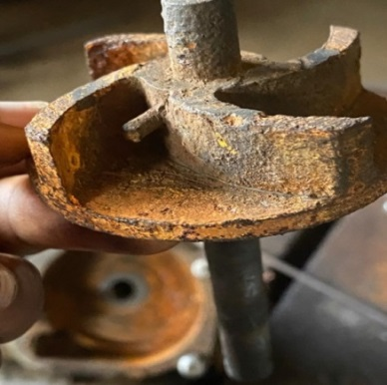 | 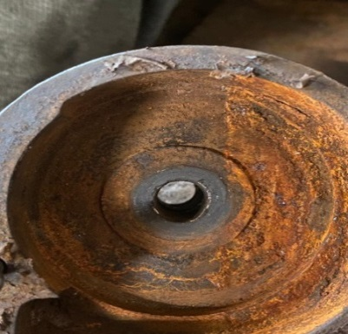 | 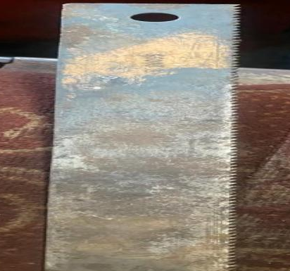

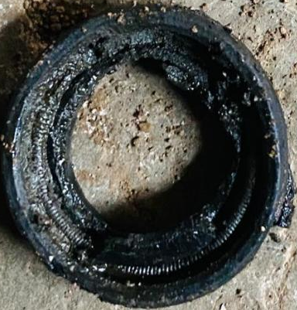 | 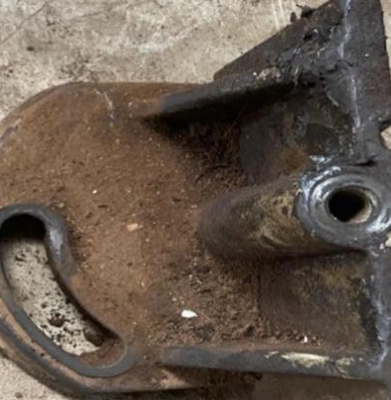
Figure 4: Failed band saw component example
Based on the information presented in Table 1, a Bowtie Diagram was constructed using BowtieXP software to structure the relationships between the Top Event, Causes, Consequences, Proactive Barriers and Reactive Barriers (Figure 5-9). It consisted of identifying the damage, hazards and accidents that could occur with each failure and the consequences that could result.
One of the risk reduction measures is to identify the barriers needed to reduce the likelihood of a particular accident occurring
Table I: Diagnosis results
No | Component | Symptom(s)
1 | Impeller | Cracks , Rust
2 | Pump Housing | Corroded and clearance of 2mm
3 | Saw blade | Broken teeth, Blond teeth
… | … | …
10 | Clamp | Cracks
11 | Seal | Leakage
… | … | …
With this comprehensive view of the risk associated with the failure of the semi-automatic band saw, it was possible to develop a Bowtie model to structure the decision-making process, such as maintenance (resuscitation of the band saw), risk management with better information visualization. Through the Bowtie, the risk faced at any given time can be managed to an acceptable level by implementing barriers to prevent an undesirable incident from occurring (Abia et al., 2019) or by limiting its consequences.
- Damaged impeller
There was rust and cracking on the surface of the impeller, which severely affected the cooling efficiency of the cutting machine. Rust obstructed airflow, reducing the impeller's ability to effectively cool the machine. Cracks also lead to further damage or failure of the impeller, resulting in inadequate cooling and potential overheating problems. Based on similar findings of impeller corrosion failure (Ul‐Hamid et al., 2015), significant rust was observed on the impeller of a water pump as a result of exposure to oxygen and moisture, which was also the case for the pump of the semi-automatic band saw machine at Rolling Enterprise.
The suggested impeller Bowtie Diagram, Figure 5, shows the preventive and mitigating controls for each of the causes. Implementing any of these controls will prevent the impeller from failing, without which there will be a reduction in pump efficiency, reduction in flow, lubricant contamination, pump failure and impeller wear. To limit the impact of this reduced pump efficiency, only a few mitigation barriers were practiced by the machine operators and maintenance personnel. It should be noted that not all controls need to be in place to prevent the hazards from occurring or to mitigate the consequences of the failed impeller,
because ideally, the control measures, or barriers should be independent of each other to avoid any common mode of failure (Xie et al., 2018).
- Pump Housing
A clearance of 2 mm in the casing, another important part of the pump (Olorunfemi et al., 2018), shown in Figure 4, was found between the impeller shaft and the pump casing ideal, which resulted in reduced pump efficiency. A Venier caliper was used to measure this clearance. The clearance in the pump casing indicated excessive wear or improper assembly. This clearance resulted in reduced flow and leaks or malfunctions in the cooling system.
Figure 6: Bowtie diagram of a pump housing
Figure 6 shows some of the preventive and mitigating controls that can be put in place to reduce the impact of the consequences and prevent the pump from failing. It shows on the left and right, respectively, the mitigating and preventive controls that can be implemented to prevent the hazard from occurring, and the mitigating barriers that can limit or reduce the impact of the consequences that can result from foreign matter entering the pump as observed during the diagnosis (Figure 4).
- Saw Blade
The saw blade had broken and blunt teeth, resulting in poor cutting performance. Comparing the results of the diagnosis with the modeling of wear and blunt blade transformations (Zhuo et al.,2022), the diagnosis of a saw blade revealed that the blade was warped and bent when visually inspected or when its straightness was measured using tools such as precision straight edges. Figure 7 shows the bowtie diagram for the saw blade with recommended prevention and mitigation measures.
Figure 7: Bowtie diagram of a saw blade
- Clamp
Visual inspection of the clamp revealed cracks that compromised the safety and functionality of the machine. That is, its ability to securely hold the work piece during cutting becomes questionable. Replacement/repair of the clamp was required to ensure proper and secure holding of the work piece during cutting. Figure 8 shows the Bowtie diagram for a cracked clamp on the band saw as observed during inspection (see Figure 10, weld clamp) with preventive and mitigating barriers.
Figure 8: Bowtie Diagram of a Clamp
- Pump Seal
Poor sealing of the pump seal caused fluid loss and reduced pump efficiency. This resulted in an ineffective seal, which led to fluid loss and reduced pump efficiency. Leaks also caused problems throughout the cooling system. Repair or replacement of the pump seal was necessary to prevent further damage and ensure proper operation (Shiels, 2002). Figure 9 shows the Bowtie diagram for the seal on the cooling system of the semi-automatic band saw machine. The seal was worn out.
Figure 9: Bowtie diagram of a pump Seal

Root causes from Bowtie diagram
The root cause corrective action process is a valuable tool for maintenance professionals who want to address and prevent problems in a structured and systematic way. The root causes of previously reported failures were identified using the bowtie diagram because the threats in the bowtie diagrams in Figures 5-9 correspond to the root causes.
- Impeller
From the Bowtie diagram for the impeller, the presence of rust and holes on the impeller of a water pump led to a failed impeller. Rust is known to create rough surfaces and irregularities on the impeller blades, which disrupts the flow of fluid (Zhuo et al., 2022, Zariatin et al., 2019). The underlying factors or hazards that led to this failed impeller include;
- Inadequate maintenance: If a centrifugal pump is not properly or regularly maintained, there is a high probability that individual components such as the impeller will fail. Of the 6M categories (Aust and Pons, 2020), this root cause was method, meaning the maintenance procedures and processes were not the best to prevent rust from affecting the impeller blades. The Bowtie diagram in Figure 5 provided controls that should be used to prevent this particular threat from occurring; training personnel on proper pump maintenance, performing regular inspections and others from the left side of the Bowtie.
- Foreign Objects: The impeller could have failed because the working environment (Mother Nature) was not conducive, an example is when iron fillings get into the pump during cutting, causing abrasion, metals rubbing against each other causing wear. When these foreign bodies such as iron
fillings enter the water pump, it reduces the flow rate of the fluid or lubricant because the impeller transfers some of the energy received from the motor to the foreign particles and their presence has already contaminated the fluid leaving the centrifugal pump.
- Poor Quality Pump: The material of the pump was not the best and this could cause the impeller to fail and eventually cause the pump to fail completely. The barriers to mitigate and prevent this cause are shown in the Bowtie diagram (Figure 5).
- Air entering the pump: The impeller transfers energy from the motor to the fluid and during this process there is a change in temperature, so if air gets into the pump while the impeller blades are rotating, it will create bubbles and when they collapse it will cause cavitation wear which will eventually cause the pump to fail. This cause was caused by Mother Nature according to the 6M categories.
- Pump Housing
The Bowtie diagram of the pump housing (Figure 6), which has a clearance of 2mm and was experiencing rust as shown in Figure 3, originated from one of the following causes:
- Lack of regular inspection: A machine or component cannot run optimally for weeks, months and years if it isn't inspected from time to time. The lack of regular inspection on the pump casing resulted in a 2mm clearance between the impeller shaft and the pump casing bushing. This resulted in further damage to the brass bushing in the pump casing.
- Inadequate repair and replacement procedures, training and awareness could also have resulted in reduced pump efficiency and performance, which could have further resulted in unplanned downtime of the semi-automatic machine.
- Improper pump installation and/or inadequate protective coating, such as anti-rust paint, may also have caused clearance in the pump casing; vibration that can damage the impeller shaft and result in increased maintenance costs.
- Saw Blade
The saw blade damage with blunt and broken teeth as shown in Figure 4 resulted in the saw blade becoming stuck during operation. The causes of this top event were improper use of the blade because the band saw blade has been used to form keyways on pulleys, causing the blade to lose some of its teeth and become blond. This cause is man-made and results in damage to the work piece because the cuts are very rough.
- Clamp
Clamp damage due to fatigue and wear caused by constant stress and strain on the clamp, resulting in cracks in the clamp that can cause accidents during operation. The use of inferior clamps, overloading of the clamp, and improper installation are also factors that can cause the clamp to crack.
- Seal
The seal had been used without maintenance, causing it to wear out and leak fluid, and other factors that caused the seal to leak included improper installation and the use of inferior seals.

Corrective actions
Cleaning and descaling were the initial corrective actions for the rusted impeller. After cleaning the impeller, a rust inhibitor was applied to the surface of the impeller blade to dissolve and remove any remaining scale. After corrosion prevention and rust removal techniques in steel structures (Gowri-Shankar and Ponnsahana, 2021), the impeller was then polished/grinded with sandpaper. By removing the uneven surfaces caused by rust, the impeller regained its original shape and improved performance. Rust inhibitor was then applied and left to cure in the sun to protect the machine part from rust and corrosion, thereby extending its life and reducing maintenance costs (Thompson et al., 2007).
Corrective action to maintain the pump casing included cleaning it with detergent and an iron brush. Rust inhibitor was sprayed on the pump casing to dissolve any rust deposits. The iron brush was then used to remove any remaining rust. The casing was then sanded to remove any uneven surfaces (Gowri-Shankar and Ponnsahana, 2021). A 12 mm brass cone was mounted on a lathe (see Figure 10) and turned to reduce the outside diameter by 2mm. The steel cone was then mounted into the pump housing and pressed by hand to fill the space in the pump with clearance.
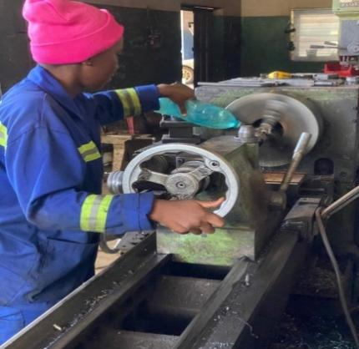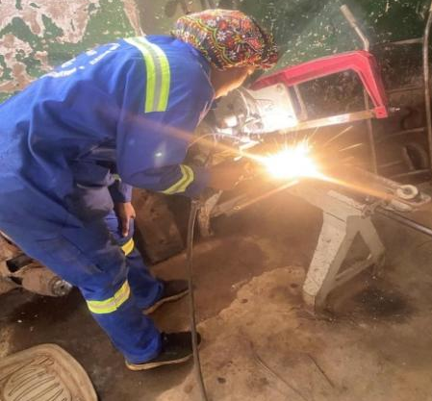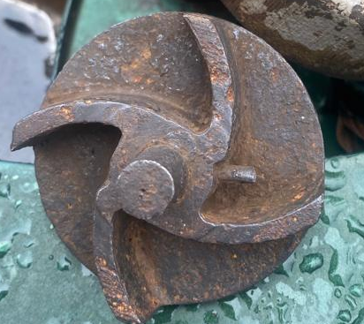
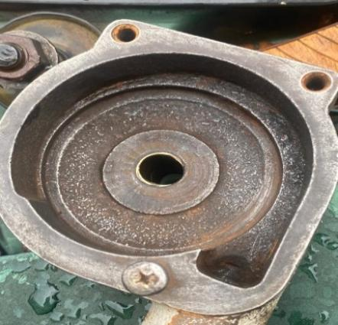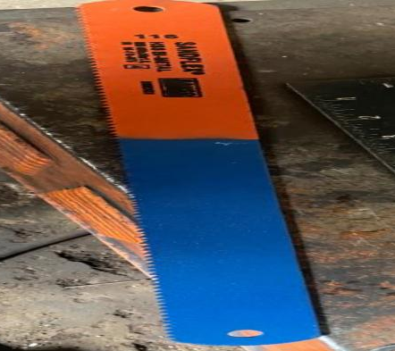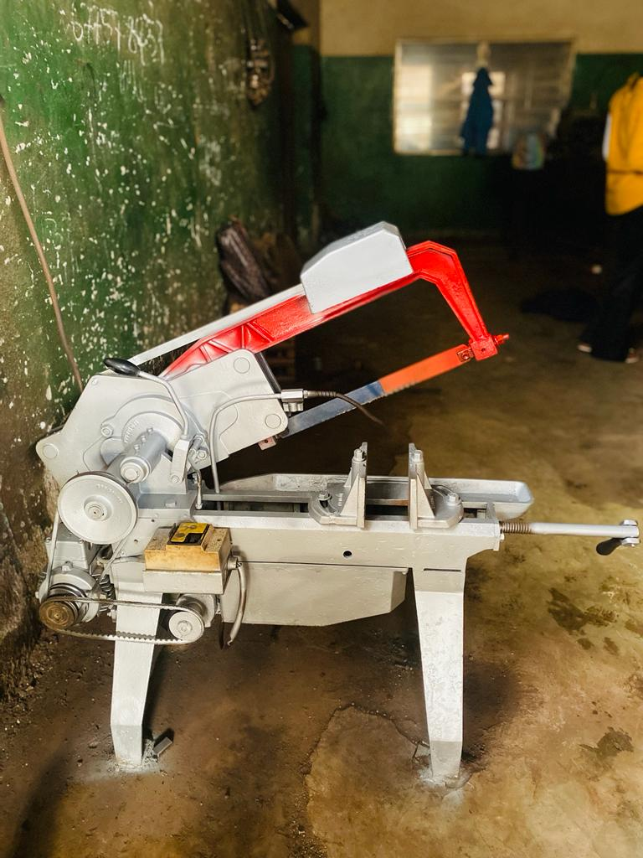
Figure 10: Maintenance: resurfacing brass cone, welding clamp, maintained parts
It was critical to replace the saw blade with a new one suitable for the specific application. The saw blade was replaced by purchasing a new blade as shown in Figure 10. The new blade was then installed and properly tensioned using a wrench. Corrective action on the clamp included cleaning with a liquid chemical and an iron brush. The clamp was then allowed to dry and CHE-40 electrodes were used in conjunction with a welder to fill in the cracks. An angle grinder was then used to smooth the surface of the clamp.
Table 2: Summary of Corrective actions carried out
Main Corrective Actions | State of Resolution | Verification Method
1. Impeller was sand papered to ensure smooth surface and sprayed with anti-rust | operational | Poured lubricant into tank and impeller was able to provide energy to move the lubricant
2. Pump housing was filled with brass material | Failed | The impeller shaft and the housing had spacing between them
3. Saw blade replaced | Operational | Cut various pieces of different dimensions
4. Clamp was welded using Sarf 40mm electrode | Operational | Held different pieces together
6. Pump Seal replaced | Operational | No leakage on the pump when lubricant is placed in it
A new gasket was then designed on solid blocks and tests were conducted to determine the best material to form a gasket. In the first test, a slipper (PVC) was cut with an industrial blade and used to form a seal. After the seal was installed, there was severe leakage at the pump outlet and the lubricant could not flow because the seal could not withstand the pressure from the impeller. In the second test, an EPDM synthetic rubber from automobile tires was used to form the seal. The seal was able to withstand the pressure from the impeller, allowing the lubricant to flow more efficiently to the blade.
Table 2 summarizes the main activities for maintaining the band saw, while Figure 11 shows the band saw after corrective action and ready for control testing. According to the corrective actions performed, PVC plasticizes and becomes brittle and even shatters at certain temperatures, whereas EPDM synthetic rubber can withstand certain temperatures and pressures.
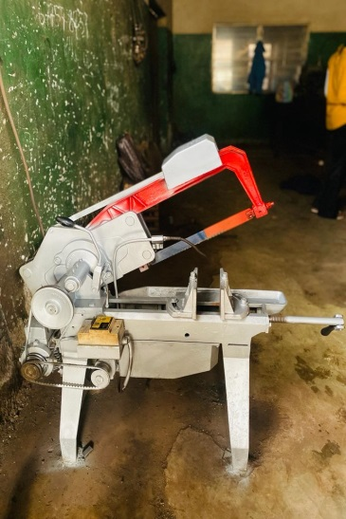
Figure 11: Band saw after Maintenance

Monitoring and evaluation
The performance rate, which compares the time the machine should be cutting (ideal time) to the actual time the machine spent cutting 60x30mm round tubing, was 93% (Table 3). This indicates that the machine was achieving 93% of its maximum speed or output efficiency; therefore, it was operating close to its optimum performance level with minimal downtime, interruptions, or inefficiencies that would affect its overall productivity.
Table 3: Performance Calculation
Operating Time Per Shift (min) | 21 | 22 | 20.3 | 22.7 | 22
Output per shift (Numbers) | 6 | 6 | 6 | 6 | 6
Ideal Cycle time | 4 | 4 | 4 | 4 | 4
Performance rate | 0.9523 | 0.909 | 0.985 | 0.881 | 0.909
Average Performance | 0.927
$$Performance rate = \frac{Units produced in the total shift time}{Number of expected units to be produced} x 100≈93\%$$

Conclusion
The main objective of the research was to restore the semi-automatic band saw machine owned by Rolling Enterprise to a functional state with improved reliability. After conducting a comprehensive analysis, numerous conclusions were drawn from the research. The results showed that the malfunction of more than 11 components, including the impeller, pump housing, seal, saw blade, clamp, bearings, gears, belts, and motor, prevented the machine from working successfully. After using Bowtie diagrams, a visual risk assessment tool, to analyze potential hazards or root causes, it was determined that the failures were due to several factors, including poor maintenance, the presence of foreign objects such as iron filings, poor quality of certain components, fatigue, wear and numerous others. Through the use of diagnostics, root cause analysis and corrective maintenance, a successful resuscitation of the semi-automatic band saw was achieved. It was imperative to demonstrate that the methods used in the research could be implemented by numerous manufacturing and production companies to optimize the maintenance and effectiveness of their production equipment.
Acknowledgement
The authors acknowledge the support received from Mr. Simon Ngumbi Audi, Manager of Rollings Enterprise, which enabled the timely completion of this research.

References
Abia, D., Iwegbu, M., Onofeghara, C. and Anozie, I. 2019. Effective Barrier Risk Management in Process Safety Utilizing the Bow Tie Methodology. In SPE Nigeria Annual International Conference and Exhibition (p. D033S021R005). SPE.
Alisinoglu, MB., Sogut, SA., and Seker, U. 2019. Determination of industry 4.0 compliance criteria for band saw machines. Industry 4.0, 4(6): 277-281.
Aust, J., and Pons, D. 2020. A systematic methodology for developing bowtie in risk assessment: application to borescope inspection. Aerospace, 7(7): 86.
Gowri Shankar, KS.and Ponnsahana, KR. 2021. Techniques on Corrosion Prevention and Rust Removal on Different Steels. In Materials, Design, and Manufacturing for Sustainable Environment: Select Proceedings of ICMDMSE 2020 Springer Singapore. (pp. 251-260).
International Civil Aviation Organization (ICAO) 2012. Safety Management Manual (SMM), 3rd ed.; ICAO:Montreal, QC, Canada.
Ispășoiu, A., Milosan, I., ISPĂȘOIU, AMF. and Meiță, C. 2021. Study on the application of the Bowtie methodology for the assessment of ergonomic risks in the Industrial Field. RECENT-REzultatele CErcetărilor Noastre Tehnice, 22(3): 128-136.
Kohale, U., Adhao, S., Thakare, D., Panchawate, A., Dalvi, S. and Akarte, P. 2022. Design and Fabrication of Motorized Hacksaw Machine. International Journal for Research in Applied Science & Engineering Technology, 10 (5): 3697-3703.
Kuldipia, K., Ram, EJ., Murmu, MK., Das, AK. and Sahoo, A. 2023. Design of a high speed 4-way hacksaw machine. International Research Journal of Modernization in Engineering Technology and Science, 5(7): 879-883.
Liu, Y. 2020. Safety barriers: Research advances and new thoughts on theory, engineering and management. Journal of Loss Prevention in the Process Industries, 67, 104260.
Olorunfemi, BJ., Adejuyigbe, SB. and Adekunle, AA. 2018. Casting and Performance Evaluation of Pump Impeller and Housing using Local Raw Materials. FUOYE Journal of Engineering and Technology, 3(1): 7-11.
Patil, RB. and Waghmode, LY. 2014. Life Cycle Cost (LCC) Optimization of Band Saw Cutting Machine through Reliability Analysis. Proceedings of 1st International Conference on Mechanical Engineering: Emerging Trends in Engineering, 2: 755-763.
Shiels, S. (2002). Failure of mechanical seals in centrifugal pumps. World Pumps, 2002(429), 20-22.
Tsapi, TK., Nanah, NG., Kuiate, GF. and Oru, BR. 2024. Using Ishikawa Method in Power Hacksaw Maintenance. International Journal of Innovative Science and Research Technology, 9(2): 128-135.
Xie, L., Lundteigen, MA. and Liu, YL. 2018. Safety barriers against common cause failure and cascading failure: literature reviews and modeling strategies. In 2018 IEEE International Conference on Industrial Engineering and Engineering Management (IEEM) (pp. 122-127). IEEE.
Xue, T., Liu, Y., Li, G. and Zhao, G. 2024. Effect of heat treatment on microstructure and properties of bimetallic band saw blade. Journal of Physics: Conference Series, IOP Publishing, 2691(1): 012074.
Ul‐Hamid, A., Al‐Hadhrami, LM., Mohammed, AI. and Al‐Yousef, FK. 2015. Failure analysis of an impeller blade. Materials and Corrosion, 66(3): 286-295.
Zariatin, DL., Rahmalina, D., Prasetyo, E., Suwandi, A. and Sumardi, M. 2019. The effect of surface roughness of the impeller to the performance of pump as turbine pico power plant. Journal of Mechanical Engineering and Sciences, 13(1): 4693-4703.
Zhuo, R., Deng, Z., Chen, B., Liu, T., Ge, J., Liu, G. and Bi, S. 2022. Research on online intelligent monitoring system of band saw blade wear status based on multi-feature fusion of acoustic emission signals. The International Journal of Advanced Manufacturing Technology, 121(7-8): 4533-4548.

